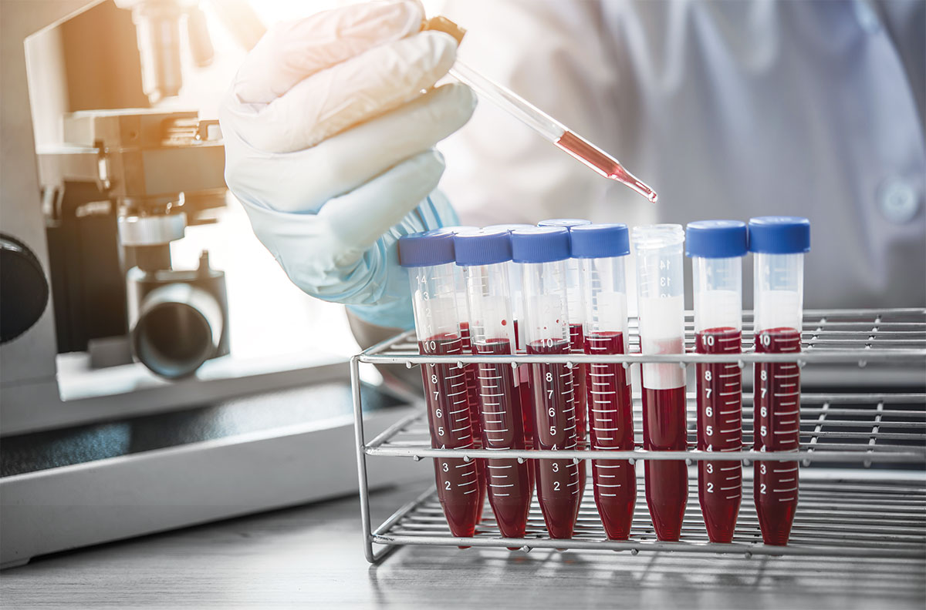
Understanding direct access labs and multiphasic blood analysis

Mon Health thanks you for participating in the direct access labs or the multiphasic blood analysis events. These tests can be early indicators of health problems, including coronary heart disease, diabetes, liver disease, kidney disease, thyroid disease and other disorders.
The results are for informational purposes only. Consult your physician if one or more of the screenings are abnormal. If you do not have a primary care physician, visit monhealth.com/primarycare to make an appointment.

Complete Blood Count

WBC - White Blood Cells
These cells circulate in your bloodstream and play an important role in your immune system by fighting infections, bacteria and viruses. Decreased values may indicate a breakdown in the immune system. Increased levels may indicate infection.

RBC - Red Blood Cells
These cells carry oxygen throughout your body. Increased values may indicate dehydration. Decreased values may indicate anemia.

HGB/ HCT - Hemoglobin/ Hematocrit
Hemoglobin carries oxygen in the blood. Low levels may indicate anemia.

MCV- Mean Corpuscular Volume
Average volume of red blood cells. Abnormal values may indicate certain nutritional deficiencies, such as iron and B12/Folate.

Platelet Count
Platelets help the blood clot. Increased levels could indicate bleeding or a blood disorder. Decreased levels could lead to bleeding tendencies such as easy bruising.

Chemistry Panel

Chloride
Chloride is a type of electrolyte. It works with other electrolytes such as potassium, sodium and carbon dioxide to help keep the proper balance of body fluids and maintain the body's acid-base balance.

CO2
When levels are higher or lower than normal, it suggests the body is having trouble maintaining its acid-base balance or there is an upset in electrolyte balance from either losing or retaining fluid. These imbalances may be due to a wide range of dysfunctions.

Glucose Level
Glucose provides the energy our bodies need. High glucose levels can indicate diabetes. Low glucose levels can indicate hypoglycemia.

BUN - Blood Urea Nitrogen
Measures the amount of nitrogen that comes from the waste product urea. Urea is formed when protein breaks down and is produced by the liver and eliminated by the kidneys. High levels can indicate kidney injury or disease, or can be caused by some medications. Low levels can be caused by pregnancy or kidney disease.

Creatinine
Evaluates kidney function. High levels can indicate serious kidney damage or disease. Low levels can indicate a decrease in muscle mass or severe liver disease.

eGFR - estimated Glomerular Filtration Rate
Can detect kidney disease at an early stage. If detected early, it may be possible to prevent more damage if it is caused by high blood pressure, diabetes, or other treatable diseases.

Potassium
Potassium is a vital electrolyte in the blood. Electrolytes maintain water balance and keep the kidneys functioning properly. High levels may indicate kidney damage. Low levels can be caused by poor diet or significant water loss from the body such as vomiting, diarrhea or heavy sweating. Levels too high or too low can also cause abnormal heart rhythms, muscle cramps/weakness, confusion or paralysis.

Sodium
Sodium is the most important mineral in your body. High levels may be caused by high blood pressure, heart disease and kidney damage. Low levels may be caused by poor diet, diuretics, or significant water loss from the body such as vomiting, diarrhea or heavy sweating.

Alk Phos - Alkaline Phosphatase
Helps detect or monitor liver disease. It also helps evaluate bone abnormalities.

AST/SGOT - Aspartate Aminotransferase
Helps to diagnose liver disease. High levels can indicate recent or severe liver, kidney, or lung damage, heart failure, or heart attack. Low levels can indicate a vitamin B6 deficiency.

ALT /SGPT - Alanine Aminotransferase
Helps to detect liver damage or disease. High levels may indicate poor blood flow to the liver or liver damage. Low levels can indicate a urinary tract infection or malnutrition.

Total Bili - Total Bilirubin
Evaluates liver function or the effects of medication that can cause liver damage. It can also determine if there is a blockage of the bile ducts, which can be caused by gallstones and other conditions.

Calcium
Used to measure a range of conditions relating to the bones, heart, nerves, kidneys, and teeth. Blood calcium levels do not directly tell how much calcium is in the bones, but rather how much calcium is circulating in the blood. Elevated levels can indicate hyperparathyroidism. Low levels can indicate a vitamin D deficiency or pancreatitis.

Total Protein
A combination of albumin and globulin produced by the liver and immune system to fight infections. Elevated levels may indicate rare blood cancers, kidney or liver disease, dehydration, or a chronic infection. Low levels can indicate malnutrition, Crohn's disease, and hyperthyroidism.

Albumin
Albumin is a protein made by the liver and is necessary for maintaining the pressure in blood vessels to prevent blood fluids from leaking out. Elevated levels can indicate dehydration. Decreased values may indicate excess fluid that collects in the ankles, lungs or abdomen.

Lipid Profile

Cholesterol
Cholesterol is the fat found in eggs, meat, and butter which is directly related to the hardening of the arteries (atherosclerosis), heart disease, and heart attacks. Total cholesterol refers to the total amount of high-density lipoprotein (HDL) and low-density lipoprotein (LDL) cholesterol in the blood. A total cholesterol of less than 200 mg/dL is desirable.

What affects cholesterol levels?
- Diet - Saturated fats in the foods you eat can make your cholesterol high.
- Weight - Being overweight can be a risk factor for heart disease. Losing weight can help lower your LDL levels and total cholesterol, as well as raise your HDL levels.
- Physical Activity - Regular physical activity, 30 minutes on most days, can help lower LDL levels and raise HDL levels.
- Age & Gender - As men and women age, their cholesterol levels rise. Before menopause, women's LDL levels tend to be lower than men of the same age. After menopause, women's LDL levels tend to rise.
- Heredity - Genes partly determines how much cholesterol your body makes. High cholesterol can run in the family.

Triglyceride
Triglycerides are a type of fat found in your blood. When you eat, your body uses the calories it needs for quick energy. Any extra calories are turned into triglycerides and stored in fat cells to be used later. If you regularly eat more calories than you burn, you may have high triglycerides. Elevated levels may increase the risk for developing coronary heart disease. A triglyceride level of less than 150 mg/dL is desirable.

What affects triglyceride levels?
Smoking, being overweight, alcohol consumption, lack of exercise, high carb diet, Hypothyroidism.

HDL - High-Density Lipoprotein
This "good" cholesterol helps prevent fat from building up in the arteries. HDL is made up of mostly protein and helps clear the "bad" cholesterol (LDL) from the body.

LDL - Low-Density Lipoprotein
This "bad" cholesterol is mostly fat and can clog the arteries which can lead to an increased risk of coronary heart disease.

VLDL - Very Low-Density Lipoprotein
Distributes the triglyceride produced by your liver. A high VLDL cholesterol level can cause the buildup of cholesterol in your arteries and increases your risk of heart disease and stroke.

Other Screenings

PSA - Prostate Specific Antigen (Men Only)
Prostate Specific Antigen is a protein produced by the cells of the prostate gland. The PSA test may be used to detect or monitor prostate cancer. High PSA levels may indicate prostate cancer or an enlarged or inflamed prostate.

TSH - Thyroid Stimulating Hormone
Used to check for thyroid gland problems. High levels may indicate an underactive thyroid gland (hypothyroidism) and may cause weight gain, tiredness, dry skin, and constipation. Low levels may indicate an overactive thyroid gland (hyperthyroidism) and may cause weight loss, rapid heart rate, nervousness and diarrhea.

Hemoglobin A1-C
Reflects your average blood glucose level over a 6-12 week period and is typically used as a monitoring tool for those diagnosed with diabetes.

Vitamin D
(Not available at all multiphasic screenings) Vitamin D is involved in the regulation of calcium. It plays a vital role in the formation and maintenance of strong healthy bones. In recent years, Vitamin D has become a measurement of general health status, with a deficiency being linked to cancer, cardiovascular disease, diabetes and autoimmune diseases.

Vitamin B12 and Folate
Vitamin B12 and Folate are two vitamins that are part of the B complex of vitamins. B12 and folate work with vitamin C to help the body make new proteins. They are necessary for normal red blood cell (RBC) and white blood cell (WBC) formation, repair of tissues and cells, and synthesis of DNA. Both are nutrients that cannot be produced in the body and must be supplied by the diet.

Phosphorus
Phosphorus is a mineral obtained mostly from food. It helps form healthy bones, teeth, process energy in the body, and supports muscle and nerve functioning. Levels may help assess kidney, gastrointestinal and nutritional disorders or calcium and bone problems. Calcium and phosphorus work together in the body and the levels of one can yield important information about the other.

Magnesium
Abnormal levels of magnesium are most frequently seen in conditions or diseases that cause impaired or excessive excretion of magnesium by the kidneys or that cause impaired absorption in the intestines. Elevated levels may indicate gastrointestinal disorders such as Crohn's disease. Low levels may indicate kidney failure or Addison's disease.

Uric Acid
Produced by the breakdown of the body's cells. Elevated levels may indicate kidney stones or gout. Alcohol intake may also increase this value.

Iron
Identifies how much iron is being carried through the blood. High levels may indicate excess dietary intake or liver disease. Low levels may indicate anemia.

For more information on Direct Access Labs and Multiphasic Events, please visit MonHealth.com/HealthFair.

Direct Access Lab Testing

Direct Access Lab Testing allows patients to obtain testing and results for a variety of tests without a physician order. These tests can be an early warning of health problems, including coronary heart disease, diabetes, liver disease, kidney disease, thyroid disease, and other disorders.

Locations:

- Mon Health Marion Neighborhood Hospital I White Hall, WV
Monday - Friday 8AM - 5PM
---MyMonHealth
https://www.monhealth.com/main/mymonhealth-patient-portal

- Mon Health Medical Center I Morgantown, WV
Monday - Friday 8AM - 5PM
---MyMonHealth
https://www.monhealth.com/main/mymonhealth-patient-portal

- Mon Health Preston Memorial Hospital I Kingwood, WV
Monday - Friday 7 AM - 5PM
---MyCareCorner
https://www.monhealth.com/preston-memorial/patient-portal

- Mon Health Stonewall Jackson Memorial Hospital I Weston, WV
7 days a week, 24 hours a day
---The Healthelife Patient Portal
https://www.monhealth.com/sjmh/sjmh-patient-portals

Results can be accessed via the patient portal of the Mon Health Direct Access Lab location that completed the testing.

Close-To-Home care
EMERGENCY CARE  • Back, neck or head injury  • Broken bones with dislocation  • Chest pain  • Difficulty breathing  • Head trauma  • Severe burns, pains or allergic reactions | Morgantown  Kingwood  Weston  Grafton  White Hall
PRIMARY CARE & URGENT CARE  Same-day Appointments or Routine Care  - Allergies  - Bladder infection  - Bug bites or stings  - Ear pain  - Lacerations and cuts (minor)  - Pinkeye  - Sinus infection or sore throat  - Sun burn (minor)  - Sprains or strains  - COVID-19 Testing  - Immunizations  - Vaccinations  - Sick visits  - Ongoing or follow-up care  - Management of chronic conditions  - Sports physicals  - Wellness visits  - & more! | Cheat Lake  Morgantown Westover/Gateway  Core  Fairmont  Fellowsville  Grafton  Reedsville  Kingwood  Weston
Stitches, x-rays, labs offered in select primary care locations

Virtual visits available
To schedule an appointment, visit MonHealth.com/PrimaryCare.

